BOSTON UNIVERSITY

COLLEGE OF ENGINEERING

ME306 INTRODUCTION TO MATERIALS SCIENCE

**LAB No. 1 Microstructural Characterization**

[Version Spring 2014]

I. Introduction

The purpose of this lab is to introduce you to metallography, or the analysis of the composition and structure of metals. You will first learn the method of preparing a sample for observation under the optical microscope and then the techniques of quantifying grain size. Various metallic samples will be analyzed to determine grain size. Additionally, you will learn how to measure the Rockwell hardness and Knoop microhardness.

II. Sample Preparation

There are five major operations for preparation of metallographic specimens:

1. Sectioning
2. Mounting
3. Grinding
4. Polishing
5. Etching

1. Sectioning

Typically an abrasive cutoff wheel is used to cut metallic samples so that they will fit into the 1” diameter molds for mounting. The wheels are rated for range of material hardness and commonly made of Silicon Carbide for nonferrous materials, Aluminum Oxide for ferrous materials or Diamond for ceramics. Uninterrupted moderate pressure of the piece against the wheel is recommended. The cutting area should be flooded with coolant prior to and during cutting to prevent heat damage to both the blade and specimen (may not apply for ceramics).

After sectioning, the specimen will have deep scratches and sharp edges or burrs. The burrs are removed using coarse 120-grit grinding paper on the wheel, with water as both a lubricant and coolant. The easiest approach is to hold the sample stationary and press the sharp edges against the wheels surface, make sure you have a firm grip on the sample or the high speed rotation and friction will cause the sample to be thrown from your hands. Rotate the edge meeting the grinding surface in a circular motion away from you until all burrs are removed. Do not worry about the scratches as they will be removed after mounting, with fine grinding and polishing techniques. Once the specimen has been deburred we proceed to step 2.

2. Mounting

Mounting is not always required. Only when the sample is too small or oddly shaped do you need to mount the sample. Decide which analytical methods are to be used first in order to choose the appropriate mounting technique. For example, a Rockwell hardness measurement cannot be performed on a mounted sample since Rockwell uses large weights and the mount is generally softer than the sample, causing depression of the sample into the mount material and making your result erroneous. Special mounting materials may also be chosen for use with scanning electron microscopes (SEM) as opposed to the standard optical microscopes we will be using in this lab. A SEM uses an electron beam instead of a light source so it requires a mount which not only can withstand the heat of the high energy electron beam but it must have a conductive surface (must be grounded so electron charge can flow from the sample surface or it will build up and interfere with the image). For conductive samples these qualities are often provided by a conductive mount material or for nonconductive mounts or samples the surface may be sputter coated with a thin layer of a conductive material (usually gold or carbon) before use in the SEM. The mounting material for use with an optical microscope does not have to meet such requirements, although it must meet size requirements to fit on the sample stage and within the lens focal range.

The most common mounting method used in this laboratory is a Beuhler two-part quick setting Acrylic system consisting of liquid and powder components. Alternatively a hot mounting press is available in the lab, however this method takes twice as long so for our purposes it is typically only used when a sample must be prepared for the SEM. The hot mounting press applies pressure and heat to both the sample and a powdered plastic (Bakelite) so the sample must withstand this environment in order to be hot mounted. This method is preferred when good mount to sample adhesion is required, for example when you wish to look at the edge properties of a material. With the Acrylic method, curing in a vacuum will increase adhesion and this allows delicate pieces or samples with gaps you wish to fill with mounting material to be mounted.

When placing a sample in a mount, you must consider what surface or edge you wish to look at and place this surface face down in the mounting cup. If mounting more than one sample of the same material, one mount can hold several samples at a time with sample clips used as spacers. Do not forget to label your samples while curing in the mount molds.

Mix 2 parts by volume of Buehler Sampl-Kwick powder and 1 part by volume of Buehler Sampl-Kwick liquid in a paper mixing cup and blend thoroughly with a stirring stick for 15-20 seconds. Try not to introduce air bubbles (this is where curing in a vacuum would come in handy, but we do not use one for this lab). Gently pour the solution onto the samples with the aid of the stirring stick to help prevent moving samples to the edge or upending them. You only need to fill up the mount enough to cover your samples; a good thickness is between 0.5” to 0.75”. Allow the epoxy to cure for 15 minutes, during this time an exothermic reaction will occur as it solidifies, and when it is cool you may push it out of the molding cup.

Once your sample is mounted you will start at the 120-grit paper wheel with running water, this will remove any mounting material that may have covered the sample surface and expose a flat region of the sample. To prevent the mounts sharp edges from catching on the polishing cloth the edges are beveled by rolling the edge of the mount along the rotating 120-grit paper wheel. Now is a good time to label your sample using the electric engraver on the back of the mount, which will not be further ground, and move on to step 3.

3. Grinding

Fine grinding removes the deformation zone produced by sectioning and coarse grinding (120-grit). In our lab, the grinding and polishing steps are performed manually, while more automated equipment is available to industry where higher quantities are analyzed (e.g. Quality Control environments). Grinding is done on the Beuhler Handimet 2 roll grinder which is fitted with four different grits sizes of SiC paper (Fig. 1). This paper is best used when kept wet with water. Begin with 240-grit, wet the paper and hold the sample firmly with the fingers. Movement should be in a straight line away from your body. A medium to moderately heavy pressure during grinding provides optimum results. Finger and wrist joints should remain rigid and shoulder line fixed to aid in even pressure control and to produce a planar surface. Once scratches are in a singular direction you have completed this step; this indicates that the layer of deformation produced during sectioning has been reduced to that left by the grit size you have ground with (Fig. 2). Wash the specimen under running water, with bar soap and a cotton ball to remove the large grit particles. Rotate the sample to grind in a new direction and repeat on papers 320, 400 and 600-grit. Regular rotation of the sample assures a planar surface and enables you to identify when the direction of the scratches on the surface has changed. Once you have completed the 600-grit paper, and washed your sample thoroughly move on to step 4.

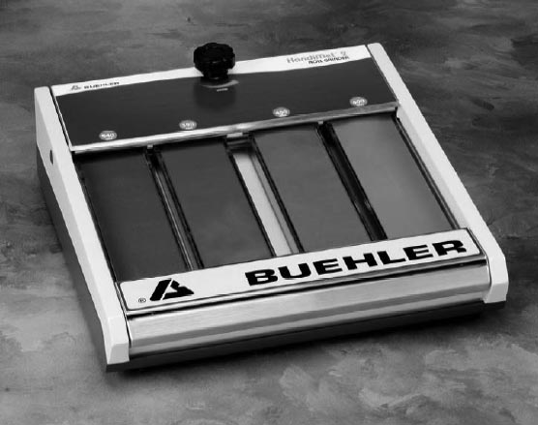

Figure 1. Handimet 2 Roll Grinder from Buehler.  
Grinding Paper Progression: 240, 320, 400, 600 (from left to right)

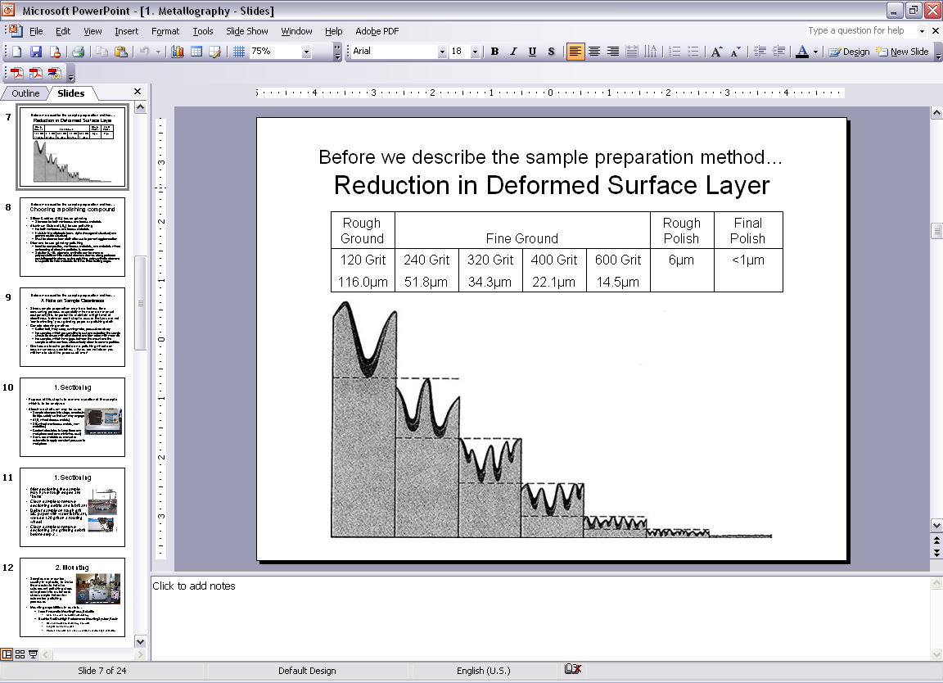

Figure 2. Step by Step Grinding and Polishing

4. Polishing

Rough polishing with 5 micron Aluminum Oxide solution removes the deformation zone produced by fine grinding (600-grit). After rough polishing, the sample will still have visible scratches – but considerably smaller than the scratches produced from previous grinding steps.

Fine polishing with 1 micron Aluminum Oxide removes the rough polishing deformation zone. The micron size of the last final polish stage required to remove all scratches depends on the magnification to be used for analysis and the sample material. Some samples may require 0.5 micron Aluminum Oxide or a finer final polish like Colloidal Silica but this is typically for use only for high magnification SEM imaging.

Begin by cleaning the polishing wheel with a brush under running water at low speed to remove metal particulate (do not mix brushes; each micron solution has its own cleaning brush to prevent contamination). Add a squirt of 5 micron Aluminum Oxide suspension. Hold the sample firmly between your fingers and press moderately to the wheel. You may increase the speed of the wheel to increase removal rate, this is your preference. Hold your wrist rigid and rotate the sample clockwise around the wheel, this moves the sample opposite the direction of rotation. Make sure not to polish at a fixed radial distance from the center, move your sample across the radius of the polishing cloth to ensure even wear. Once the scratches on the surface are no longer in a singular direction, but are fine scratches in all directions you have removed the last deformation layer left by the 600 grit, and you now only have the deformation layer left by the 5 micron Alumina suspension.

Separate wheels are used for each particle size; this is so that polishing cloths may be reused without mixing polishing particle sizes. The cloth used for each step is chosen to better hold the particle size, the 5 micron wheel has a cloth with a very short nap, the 1 micron wheel has a thicker nap, and the 0.5 micron wheel has a the thickest nap. Repeat polishing steps using 1 micron Alumina, and 0.5 micron Alumina suspensions as needed.

The wetness of the polishing wheel has an effect on the end result. If the cloth is too wet, then the sample can show pits; if too dry, buffing and/or smearing can result. To determine proper wetness, remove the sample from the wheel and check the time necessary for the polishing film to dry. In general, this should take no longer than five to eight seconds. To check for abrasive addition, note color and consistency of the film. The film should not be opaque, but rather sufficiently transparent to reveal the sample shape and luster.

Once polishing is complete, check the sample in the optical microscope. If there is minimal scratching and polishing defects move on to step 5. If there are still multiple scratches and defects continue polishing longer at the last polishing stage until it improves.

Note: Grinding papers available are 120, 240, 320, 400, 600-grit.

Polishing solutions available are 5 micron, 1 micron and 0.5 micron.

5. Etching

Etching results in the preferential attack or preferential staining of the surface. Grain boundaries are often anodic to the bulk material in the interior grain and so are etched away preferentially and delineated. Staining is produced by the deposition of solid etch product on the specimen surface.

The etching techniques that will be used in this laboratory are: immersion etching or swab etching. In immersion etching, the specimen is held with tongs and immersed in a suitable etching solution. For swab etching, the surface is gently wiped with a soft cotton swab saturated with etchant.

The specimen material determines the type of etchant used. The application time depends on how strong the etchant is, the temperature, and the reactivity between the metal and the etchant.

After the etchant application, run water over the specimen to stop the reaction. Then flush the sample with alcohol and blow dry. The alcohol flush prevents the formation of water or rust spots on sensitive materials. Repeating the final polishing will remove the effects of a faulty etch. Several grind, polish and etch repetitions may be required to produce the desired results.

The following images, in figures 3 through 5, illustrate the visual change in the surface of a copper specimen as it goes through the stages of sample preparation.

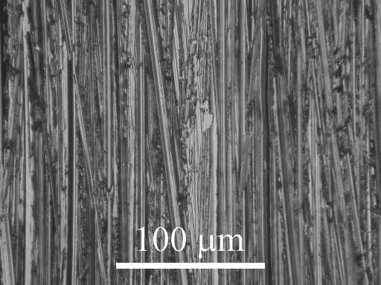

Figure 3. Copper specimen ground with 400 grit paper (Magnified at 200x)

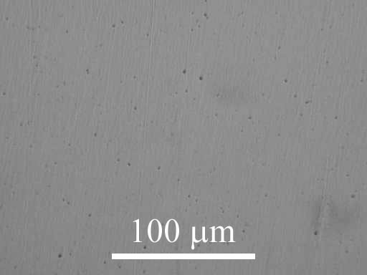

Figure 4. Copper polished with 6 micron paper (Magnified at 200x)

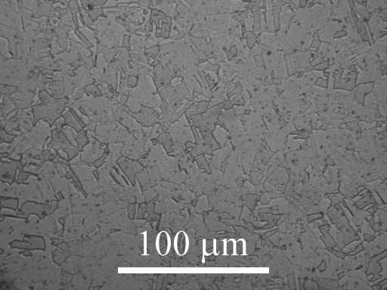

Figure 5. Copper polished and etched (Magnified at 200x)

III. Observations and Optical Microscopy

An optical microscope may be used to determine the quality of the polish and to estimate how much more time is needed at each step. Once the sample has been finely polished its surface should be mirror-like and free from scratches. As-polished samples may be examined for material porosity and polishing defects (Fig. 6). Following etching more characteristics of the sample will be revealed.

|  |  |
| --- | --- |
| “Comet tailing” dragging out of inclusions | Disturbed metal |
| Staining | Pitting |
| Relief (between different particles) | Relief (between holes and surface) |

Figure 6. Illustrations of polishing defects (Image Source: Buehler.com)

Once the sample has been prepared, it is fixed on a glass slide with plasticine and the etched surface is leveled with the help of a leveling device using a lens tissue to prevent scratching the sample.

Microstructural analysis of a material can provide information regarding the morphology and distribution of constituent phases as well as the nature and pattern of certain crystal information. The optical microscope allows one to study the distribution and morphology of the phase.

From microstructural examination, one can obtain quantitative data such as:

1. Grain size of constituent phase(s).
2. Amount of interfacial area per unit volume.
3. Ratio and distribution of phases.

The method for measuring grain size used in this lab involves the use of the scale in the eyepiece of the optical microscope. You will take measurements of grain size at several angles to ensure that your data takes into account any directionality in the grains. Choose a location on the sample surface that you consider representative and count how many grains fall along the scale, then rotate the eyepiece to change the angle of the scale and repeat for two arbitrary angles. Working in teams, each member should choose their own location on each sample and measure grain size at 3 arbitrary angles in order to increase the volume of data.

Note: Do not rotate the sample, only rotate the eyepiece. The sketches in Fig. 7 simulate a 90° rotation of the eyepiece while looking at the microstructure of a sample.

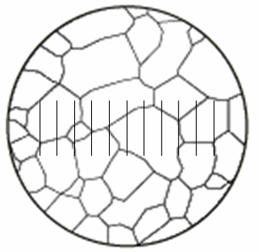 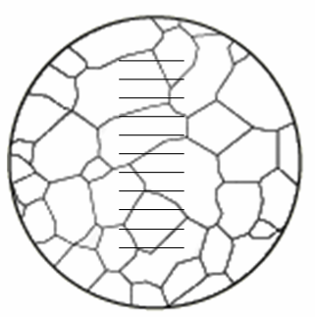

Figure 7. Rotate the sample to measure at different angles, 90° rotation shown

Each group will choose a material, examples below:

* Aluminum 4032 (2 Phases)
* Steel 1045 (2 Phases)
* Stainless Steel 316 (1 Phase)
* Free-Cutting Brass (1 Phase)

Each group will complete a set of measurements:

* Each lab group member to choose a new location on the sample
* At each location count grains per division range at 3 arbitrary angles

Notes to be made: For each measurement, make sure you note down the sample name, magnification, number of divisions on the line and number of grains counted within those divisions.

IV. Hardness Measurements

The hardness of a material is determined by comparing the depth of penetration of an indenter of known geometry with the applied load. For different levels of hardness there are different indenters and different loads. The most common hardness measurement that you will be using is the Rockwell hardness measurement. This method is for non-mounted samples and leaves relatively large indents because it uses high loads (in the kilogram range). There are two other main types of hardness measurements; Knoop and Vickers hardness. These are micro-hardness measurements because the indents are in the micron range. This method can be used with mounted samples because its uses small loads (in the grams range). The micro-hardness indenter uses a microscope to locate the desired location of the hardness measurement, applies the load and using a known scale, determines the depth of penetration by the width of the indent. As mentioned before, the geometry of the indenter is well known and can be used to calculate the amount of force necessary to create an indent of that size, which then produces a value for the hardness.

Rockwell Hardness

The Rockwell hardness indenter uses either a steel ball or diamond and applies a preload of 10kg, this sets a zero reference point and then the major load is applied. When the major load is removed the Rockwell indenter measures the permanent increase in depth with respect to the zero reference point, this is illustrated in Fig. 8. No calculation is necessary to determine the hardness number, only the appropriate scale must be read because that relates to the type and size of indenter and the force of the major load applied.

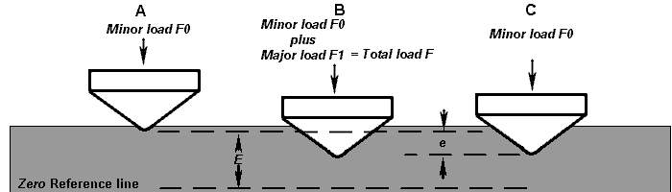

Figure 8. Rockwell Hardness Indenter (Image Source: gordonengland.co.uk)

When taking a Rockwell hardness measurement, choose an appropriate base. The base is flat for a flat sample, or a triangular crevice for a round rod. The size and type of indenter is then chosen based on which scale is being used to measure the hardness and the major load being applied. Our Rockwell equipment uses either the B or C scale; these are used for different ranges of hardness in materials, the B scale is for softer materials and we will be using this scale. As appropriate for the B scale we have a 1/16” diameter steel ball indenter and 100kg major load. The range on the scales is from zero to one hundred, if a material is harder than appropriate for the B scale it will have a hardness reading greater than 100. The units for Rockwell hardness measurement are relative and based on scales, as written they are HRB and HRC for B and C scale respectively. This stands for “Hardness Rockwell” followed by the scale identification.

Knoop Microhardness

The Knoop microhardness test uses a pyramidal shaped diamond indenter and must be performed on a polished sample. The Knoop hardness number, or KHN, is the ratio of the applied load to the unrecovered area. Using a constant (C = 0.07028) which relates the projected area of the indentation to the square of the length of its long diagonal we measure only the length of the long diagonal, shown as L in Fig. 9, and then use the formula P/CL2 to determine KHN. Where L is in millimeters and P is the applied force in kilograms. Asymmetrical indentations are invalid and are usually caused by samples that are not level with the tester stage although they may also be caused by a non-equibiaxial residual stress state.

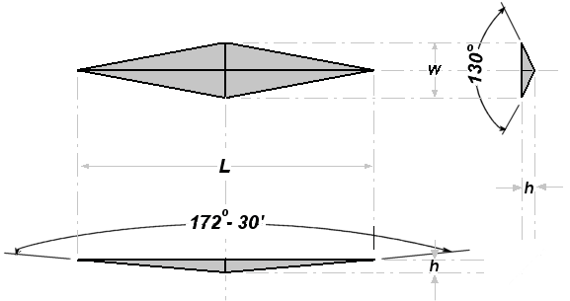

Figure 9. Knoop Hardness Indenter (Image Source: gordonengland.co.uk)

Note: Rockwell hardness is to be performed on unmounted samples only

Knoop microhardness requires a polished and level sample

Instructions

1. Observe demonstration on mounting, grinding, polishing and etching
2. Observe demonstration on identifying grains and phases
3. Observe demonstration on using hardness tester
4. Observe demonstration on using microhardness tester
5. Observe demonstration on using microscope for grain size determination
6. Observe demonstration on using microscope for digital imaging and Image J software for grain size determination
7. Split into lab groups
8. Rotate through each of the stations, detailed below
9. Compile data with other lab groups

Stations

1. Grinding (Handimet), Polishing (Wheels)
   * Prepare your own sample, as a lab group. This is for experience, not lab data.
2. Grain size (3 Microscopes)
   * Measure the grain size of the provided mounted sample
3. Hardness (2 Hardness testers)
   * Measure the hardness of the provided unmounted sample
4. Microhardness (1 Microhardness tester)
   * Measure the microhardness of the provided mounted sample
5. Imaging & Grain size software (1 Microscope with digital camera)
   * Take a digital image of the provided mounted sample
   * Use the Image J software to measure grain size, Note if there is not time to complete these measurements in lab the software is available online at **rsbweb.nih.gov/ij**

Questions

1. Describe the surface morphology (e.g. grain size/shape, number of phases, etc.) for all provided samples.
2. Make a table with the average, maximum and minimum grain size (in microns) for each sample and explain the significance of a large deviation from the average grain size in terms of grain shape.
3. Explain why the grain size is not necessarily the same in all directions. Make reference to the mounting, grain directionality and the material’s processing.
4. Compare your grain size results between the microscope scale method and the Image J software method. Are your results consistent between measurement techniques? If they are not, why might they differ?
5. Explain the basic theory behind etching. Why do we etch a polished surface? How does etching “bring out” grain boundaries?
6. What can you say about the hardness of the indenter with respect to the material being tested? What indenter material (diamond or steel?) is appropriate to test silicon carbide?
7. Explain why hardness tester readings must be taken sufficiently far away from one another and away from the specimen edges.